“Journey to Bethlehem” - A New Family Tradition
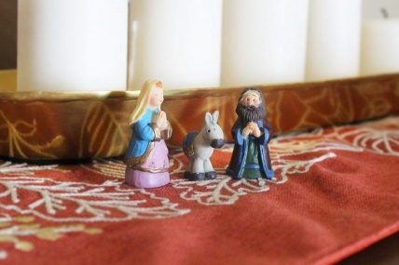

This is the perfect holiday tradition for families
If your family sets up a nativity scene, here’s how to start a new tradition that involves both parents and kids.

What Is a “Journey to Bethlehem”?
Joseph led pregnant Mary (atop a donkey) over many miles to return to his ancestral hometown of Bethlehem. With a nativity set, this “journey” can be made into a seasonal tradition that will engage your whole family from the first of December all the way to Christmas Day.
It’s a great way to count down the days to Christmas.

How to Set It Up
Setting up “Journey to Bethlehem” is simple. Start by setting up your nativity scene like normal, in a spot in the house where everyone will see it—near the hearth, on the coffee table or beneath the Christmas tree.
Don’t set Mary and Joseph up with the rest of the figurines; instead, move them around the house throughout the weeks leading up to Christmas. Every night set them up in a new location before finally completing their journey to the manger in the nativity scene on Christmas Eve. Place baby Jesus in the manger on Christmas morning.
Edited from https://www.tasteofhome.com/article/journey-to-bethlehem/
If you don’t have an advent wreath, another activity would be to invite Joseph and Mary to your dinner table each Sunday. Place them in the middle of the table, and say an extra prayer. Rotate each week who gets to say the extra prayer. After Christmas eve dinner, place Joseph and Mary in the nativity scene. Christmas morning, place baby Jesus in the manger.

What is a manger in a nativity scene?
In the Old Testament of the Bible, a manger was used to place the best lambs for sacrifice. ... A manger is also a Christian symbol, associated with nativity scenes where Mary and Joseph, forced by necessity to stay in a room for animals instead of a guest room, used a manger as a makeshift crib for the Baby Jesus.

