Preparing for Advent, a Catholic View

Preparing for Advent, Catholic
The Advent season is almost here. The beauty of Advent is that it is a season, not a day. Preparing for Advent as Catholic means that we are able to enjoy the richness of our faith which helps us to prepare our hearts and minds for celebrating the coming of the Christ child on Christmas.

What is Advent season in the Catholic Church?
First of all, it is good to review what Advent is in the Catholic Church. Advent is a four-week spiritual preparation for celebrating Jesus’ birth (and His Incarnation). Advent begins four Sundays before Christmas day. We have four weeks of Mass readings and prayers to help us focus on Jesus and what He has done for us.
The Incarnation. It is one of the most amazing truths we know. Incarnation means God made man. God, our mighty Creator, became a human. He did not just arrive on earth fully grown one day. No. He humbled Himself to be born as a baby, to be initially helpless and grow up just like we do.
God, in His infinite wisdom, love, and humility, became a man for our sake. He did not have to do this, but He chose to. This is a great act of love. We celebrate His coming on Christmas. We prepare our hearts to celebrate His coming during the season of Avent.

What does Advent prepare us for?
Celebrating Christmas-Jesus’ birth in a humble stable-is about celebrating God becoming man for our sakes. This is a lot to take in!
Advent is a gift to us. The four weeks of Advent help us to prepare us to truly celebrate Christmas, to contemplate and understand (as much as we are humanly able) the great reality of God becoming man for our sakes because of His great love for each of us.
Jesus became a man knowing ahead of time that He would suffer and die for us on the cross. His whole life on earth was dedicated to loving, teaching, and serving us so we can learn more about Him and can choose to be with Him in Heaven. His birth is a great reason to celebrate and a remarkable gift to us.
Advent gives us the opportunity to reflect more on the truths about Jesus and our Catholic faith so we can spiritually prepare our hearts for celebrating Jesus’ birth on Christmas.

How do we prepare for Advent?
This is a great question! Advent itself is a time of preparation. We do not necessarily need to prepare for Advent itself but use the time of Advent to prepare for Christ’s coming on Christmas.
Here are some ideas of things you can do by yourself and/or with your family to help you prepare during Advent for Christmas.

Pray more.
You could pray the Rosary daily, read in the Bible each day, or spend more time in personal prayer, just talking with God.
The prayers in Advent will focus on preparing for Jesus.
This Catholic Advent Prayer is a wonderful prayer for Advent.
You can find an extensive list of Advent prayers on the USCCB’s website (search for Advent prayers) as well as an Advent calendar pdf you can download and print off.

Go to Mass more often
You may want to go to Mass more often or participate in an online Mass during the week as well as on Sundays. If your parish does not have Mass online, the Daily TV Mass channel is a great resource. Attending Mass more often helps us to keep our focus on God during Advent-and less on the societal consumerism of Christmas.
You could also read the Mass readings each day. The USCCB has the daily Mass readings online for easy reference. You can even request the daily Mass readings to be e-mailed to you each day.

Go to Confession
Advent is a time of preparation. One of the best ways to prepare our hearts is to clean them. Confession cleans our souls and helps us to get our hearts in the right place in regards to others and ourselves.

Have an Advent wreath
An Advent wreath is a wreath with four candles. Usually, there are three purple candles and one pink candle. If you don’t have purple and pink candles, that is okay. You can use white ones instead. Each Sunday in Advent, one new candle is lit. Continue to light the same candle(s) each day during the week. Some families do this at dinnertime or during their daily family prayer time. If you like, you can say a prayer for the blessing of an Advent wreath when Advent begins.
You don’t need an elaborate Advent wreath. The purpose of having one is to remind you of the season we are in and to help you to keep your focus more on God.
During the first week of Advent, light the purple candle opposite the pink one. The next week, light the purple candle to the left of that one. On week three light the pink candle, then light the last purple candle on week four. You can pray at this time, too, from your heart, read the Mass readings of the day, or use prayers specific for use with an Advent wreath.
Why are there three purple candles and one pink candle? In the Church, purple symbolizes penance and rose/pink symbolizes joy. According to the USCCB’s website, “The purple candles in particular symbolize the prayer, penance, and preparatory sacrifices and goods works undertaken at this time. The rose candle is lit on the third Sunday, Gaudete Sunday . . . Gaudete Sunday is the Sunday of rejoicing, because the faithful have arrived at the midpoint of Advent, when their preparation is now half over and they are close to Christmas.”

Practice Advent traditions each year.
Do you have an Advent tradition already? Or perhaps you have thought, “one year it would be nice to do this during Advent” but have never begun. Why not start this year?
Having traditions help us keep the meaning of the celebration more at the forefront of our minds. Traditions are also something to look forward to and plan for. This brings more joy to us as well.
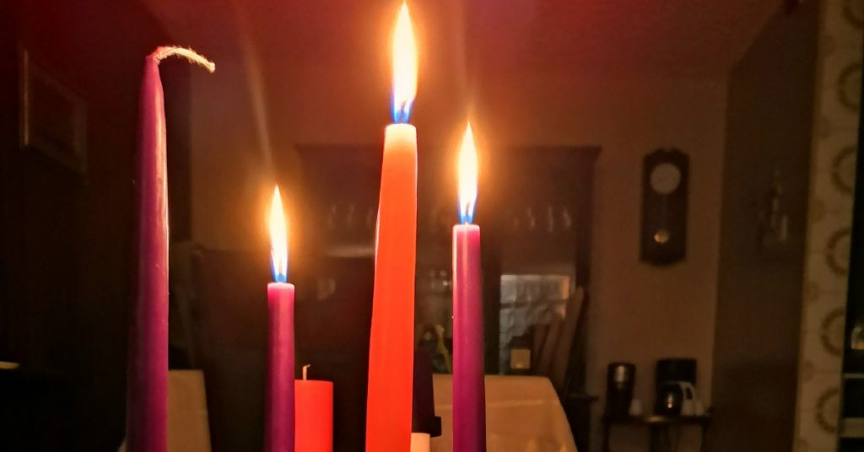

Preparing for Advent, a Catholic Perspective
There are many ways during Advent that we can prepare our hearts and minds for celebrating Jesus’ birth at Christmas. You may want to pray more, participate in the Mass during the week, have an Advent wreath, or create family traditions. No matter what you do, remember the reason you are preparing. Ask God to guide you as you anticipate the coming of His birth. He is ready to welcome you.
https://blessedcatholicmom.com/preparing-for-advent-catholic/

