What’s In a Name? Choosing a Confirmation Name

​The Importance of Picking His/Her Confirmation Name
​Spring is a busy time in the Catholic Church; not only is it the season when we celebrate Easter, it’s also the season when the sacraments of Reconciliation, Communion, and Confirmation are typically received. Those receiving Confirmation have gone through many months of instruction, reflection, and prayer. As part of the process, candidates are asked to adopt a saint name, their confirmation name, that they will carry with them throughout their life. On the day they receive the sacrament, the bishop will confirm them using their chosen saint name.
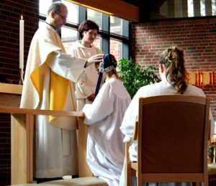

​

What is the Purpose of a Confirmation Name?
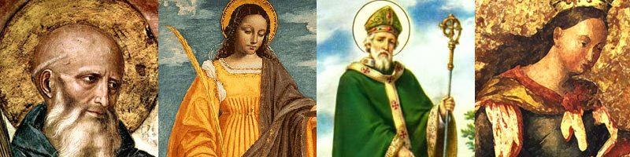
​When deciding on a Confirmation name, the goal is to pick the name of a saint you admire, can relate to, or aspire to be like. This saint will be bonded to you spiritually and will be your model in life and can be the one you turn to for guidance and protection. Throughout the Bible, there are many examples of people taking on new names, dating back to the Old Testament. God changed the names of many to reflect the special roles they’d play throughout the history of the Church. For example, God changed Abram’s name to Abraham meaning, “father to a host of nations.” This name change signified that God was making a covenant with Abraham that would make him the first of God’s people on earth. Simon’s name was changed to Peter, meaning “rock” and refers to Peter becoming the first pope: “And upon this rock I will build my church” (Matthew 16:17-18).
“And upon this rock I will build my church” (Matthew 16:17-18)
Click to Tweet

​Choosing a Saint Confirmation Name
​There are thousands of saints, how do I choose? To help you narrow down your choices to the one saint who is your ideal match, consider the following:

Pick up a book on saints
​Pick up a book on saints and read about the lives of popular saints who had a profound impact on the Church. The trials and tribulations that the saints experienced, as well as their triumphs and examples of faith, can be a great source of inspiration for your own life.

​Hobbies and Causes
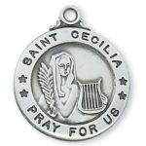
​Do you have a hobby or a worthy cause that you are passionate about? Search for the saint who shares your similar goals and interests. There is a patron saint for practically every cause. For example, if you have a special connection to animals, consider choosing the name Francis (after the great animal lover St. Francis of Assisi). If you’re looking for a saint who lived an exemplary life of selflessness, St. Maximilian Kolbe is a great example. During World War II he gave up his life for another person's life in a German concentration camp. If music is your passion, St. Cecelia — patron saint of musicians — may interest you.

​

Maybe a virtue like Bravery or Courage?
​Find a virtue that a particular saint exhibited that connects with you — bravery, obedience, charity, patience, or courage.
Do you find yourself standing up for those who need a little help? Maybe you should pick Saint Michael!
Are you well versed in bed side ​manner? Your catholic saint name would be Agatha for sure!

​Need Help? Pray!
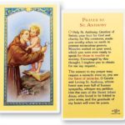
​If you’ve narrowed down your choices and are stuck and can’t decide, pray!
Ask God to shed His light on who He thinks is the best name for you.

​God Given Saint Name
​​If your first name (baptismal name) is a saint’s name, the Church allows you to use it as your Confirmation name. Doing so is actually encouraged because it’s a symbolic way of recalling your baptism.
Before you receive the sacrament, pray to the saint whose name you will be using as your Confirmation name. Ask this saint to help you to make moral choices and to be your intercessor before God whenever you call on him or her for assistance. After receiving the sacrament, don’t forget about your namesake! Remember to continue to seek his or her protection and guidance.

​Visual Reminders
​Set up visual reminders of your saintly namesake throughout your home, office, or in your car. Prayer cards, statues, books, and jewelry of your saint will help you to stay connected and to form a stronger bond.
https://www.catholicfaithstore.com/daily-bread/whats-in-a-name-choosing-a-confirmation-name/

